Lousine Kernel Registry File Format
(.LKR)

What Is A Lousine Kernel Registry File?
A Lousine Kernel Registry file is a file format used by The Lousine Kernel to track various data inside The Lousine Kernel, such as:
- System And User Settings
- Driver And Subsystem Metadata
- Device And Maintenance Information
LKR FILE HEADER:
The “LKR_FILE_HEADER” is a structure at offset 0 of the first section of the .LKR file and is defined as follows.
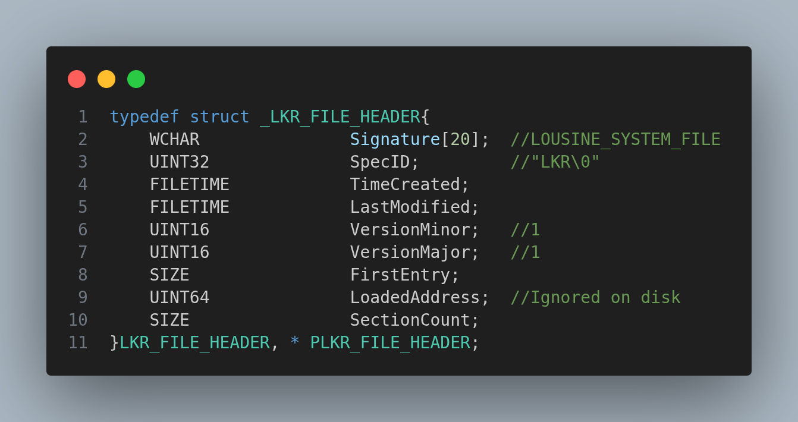
The First six items inside the LKR file are standardized in all Lousine Kernel-specific system files, also known as the LOUSINE_SYSTEM_FILE_STD_HEADER, consisting of the first 40 bytes of the file, which is an MSVC Wide String that contains the data “LOUSINE_SYSTEM_FILE”. This string must be in all Lousine Kernel system file types and is the file signature. The second item is the SpecID for the file. Each Lousine Kernel system file shall have a SpecID that identifies the class of the file for system software. The LKR SpecID is defined as “LKR\0”. After the SpecID is two FILETIME variables that correspond to the time the file was created, as well as the time it was last modified. The last two items in the LKR_SYSTEM_FILE_STD_HEADER are 16-bit variables, the MinorVersion and MajorVersion. All implementations of this software shall be set to version 1.1. NOTICE: not all versions may be backwards compatible.
The seventh item and first LKR-specific item in the LKR_FILE_HEADER is a SIZE variable that corresponds to the offset from the first byte off the file to the first byte of serialized data. The eighth item and second LKR-specific item is the LoadedAddress, which is a type UINT64 and is not relevant on the disk, only when the file is loaded into memory. The last item in the header and the third LKR-specific item in the header is the SectionCount, which is a type SIZE, and it equals the total size of the file divided by 4096. NOTICE: The total size of the file is calculated as ROUND_UP64(LastDataAddress, 4096).

